**Lab 7 – SQL**

**Each problem is worth one point. No partial credit will be given. This lab is worth a total of 20 points.**

**From this lab forward, please notice if a result table is in a particular order. If it is you must use the order by clause. Failure to do so will result in 0 points for that specific problem.**

**Place all answers into ONE .sql file and upload to Canvas.**

**Table names are not given. You must determine the correct tables.**

**\*\*\*\* Use the Student table space for the following questions \*\*\*\***

**1. Display the course revenue even if no course revenue exists for a particular course. Use a**

**Left Outer Join.**

**Partial result table (30 rows total)**

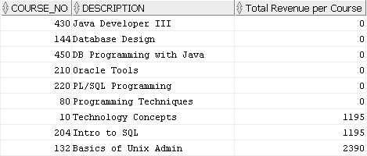

**2. Display the course revenue even if no course revenue exists for a particular course. Use a**

**Right Outer Join.**

**Partial result table (30 rows total)**



**3. Display all courses that had revenue.**

**Partial result table (24 rows total)**

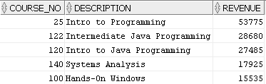

**4. (Instructor table and Section table) Use the MINUS operator to determine if any instructors are**

**not currently teaching any sections. Display the following result table. No points will be given if**

**the MINUS operator is not used.**



**5. Display all courses that cost more than 1100 and the course prerequisite is between 25**

**and 80, inclusive and the course description ends in an ‘s’.**



**6. Display the number of courses by cost.**

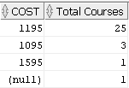

**7. Display any courses that have at least 10 characters but strictly less than 16.**



**\*\*\*\* Use the Dual table for the following questions \*\*\*\***

**8. Display today’s date formatted as per the result table. Your date will be different.**



**9. Display today’s date formatted as per the result table. Your date will be different.**



**10. Display today’s date formatted as per the result table. Your date will be different.**



**\*\*\*\* Use the Student table space for the following questions \*\*\*\***

**11. Display the most expensive course. No hard-coding of values allowed.**



**12. Format the results of problem 11 as per the result table.**



**13. Display the various results for salary as per the result table.**



**14. Display the total of the minimum and maximum salary.**



**15. Display all employees who are either managers or analysts. You must use the IN operator**

**to receive credit.**



**16. Display all student last names that sound like ‘Archer’.**



**17. Display the number of students employed by each employer.**

**Partial result table (161 rows total)**

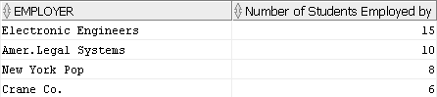

**18. Display the number of students employed by each employer. Only list those employers**

**that have more than 7 students employed.**

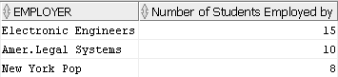

**19. Display the first 10 rows of students ordered by student id.**

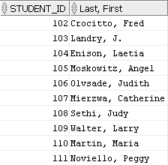

**20. Display the following result table using the Coalesce function.**

